Minto Brown Island Park/ Audubon Property
BALD EAGLE NEST Monitoring Plan

Thank you for participating in the Eagle Watch Program! The data you provide will help the City of Salem and the US Fish and Wildlife Service better balance the needs of the bald eagle pairs with recreational and park management needs. The protocols described below are an adaptation of the US Fish and Wildlife Service Region 1 “Bald Eagle Minimum Nest Monitoring Protocols - FWS R1 Suggested Methods”. They are designed to meet the specific needs and goals of this site.
As a volunteer with the City of Salem’s Eagle Watch Program, you will be asked to sign up for a weekly 2-hour observation period, according to your availability. Observation periods will be scheduled between one hour after sunrise and two hours before sunset. You will need to provide your own binoculars and/or spotting scopes and personal mobile devices (if available).
Before conducting your first monitoring visit, make sure that you have received proper training and have either downloaded the Survey123 app and installed the proper survey or have printed data sheets on hand to take into the field with you. Also make sure that you have read through and understand the Bald Eagle Monitoring Protocol as described below.
For most volunteers, data will be recorded in the Survey123 app in the field. If you do not have a smart phone or are not comfortable using Survey123 on your mobile device, data sheets can be provided for use in the field. If possible, we’d like you to transcribe your own data using the weblink provided below when you get back to your computer; however, alternative arrangements can be made if necessary. Contact Amanda Sitter at ASitter@cityofsalem.net or 503-589-2197 to request data sheets and/or plan for how to submit your data.
During your observation period, you will be doing the following:
- Occupancy survey to confirm the nest is still active/occupied.
- Behavioral monitoring, consisting of watching for activity within the line of sight (or sound for louder activities) of the eagle(s) and noting down any changes in eagle behavior.
- Taking notes on the number of trail users and types of activities occurring in the vicinity of the nest.
Survey123 link: https://arcg.is/0PK1ai

Using Survey123 in your web browser (desktop method): A webpage should open when you click the link above that asks if you want to open the app in a web browser or the Survey123 app. To complete the survey on your computer, click “Open in web browser”.
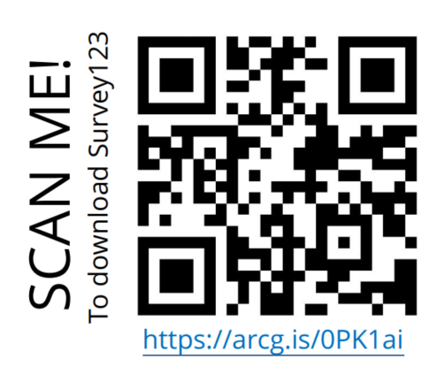
Setting up Survey123 on your mobile device for the first time: When working on a mobile device, use of the Survey123 app is recommended. You can download the app for free from your device’s app store (search “ArcGIS Survey123”). Once the app is downloaded, use the url above or the QR code to the right to open the survey.
When asked if you want to open it in your web browser or in the app, select “Open in the Survey123 field app”. On the login page, select the last option “Continue without signing in”. The questionnaire should then open on your phone. Go ahead and look through the survey at the questions that you will be asked to answer in the field. Then close the window by clicking the X in the upper left corner and select “Close and lose changes” (assuming you have not yet collected/entered any data). Now that you opened the “Bald Eagle Nest Monitoring” in your Survey123 app once, it will continue to be available directly through the app moving forward. When you are ready to record data, simply open the Survey123 app and open the Bald Eagle Nest Monitoring survey.

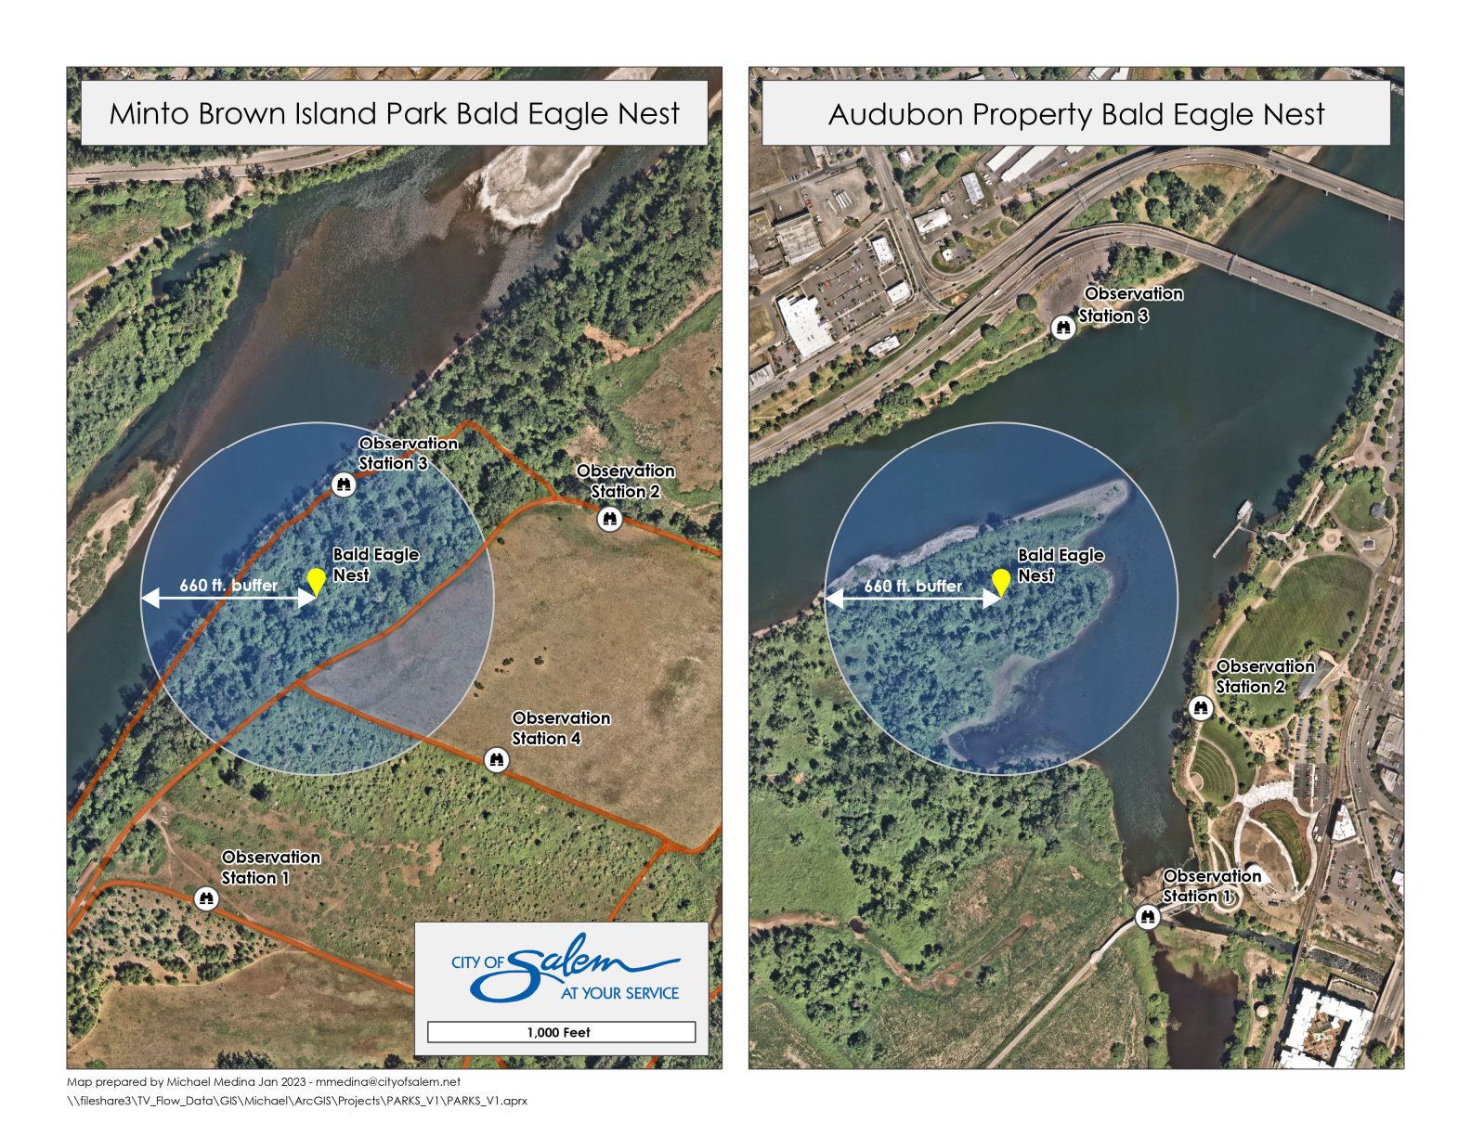

Monitoring Protocol Steps:
- Visit your assigned observation station weekly on your assigned day and time. Make sure to bring your binoculars and/or spotting scope and a mobile device (i.e., your cellphone, ipad, or tablet) with the Survey123 app downloaded and ready to use.

  - Visits should be a minimum of 2 hours in length. If it takes you longer than 2 hours to determine if the nest is active/occupied and you have the time and inclination to stay longer, you are welcome to do so. Just make sure to record the full survey duration in Survey123.
  - It is recommended that you open up your Survey123 app at the beginning of your observation period and record your location, date, and start time right away. You can save the survey as a draft and come back to it throughout the survey to record additional information. To save the survey as a draft, touch the “X” in the top left corner of the screen. A dialogue will open that asks if you want to Close and lose changes, Continue this survey, or Save in Drafts. Select “Save in Drafts”.
How to Record Your Observation Location: the survey is programmed to pick up your current location if you have location services enabled on your device. Always check the map to make sure you are reporting the correct location.
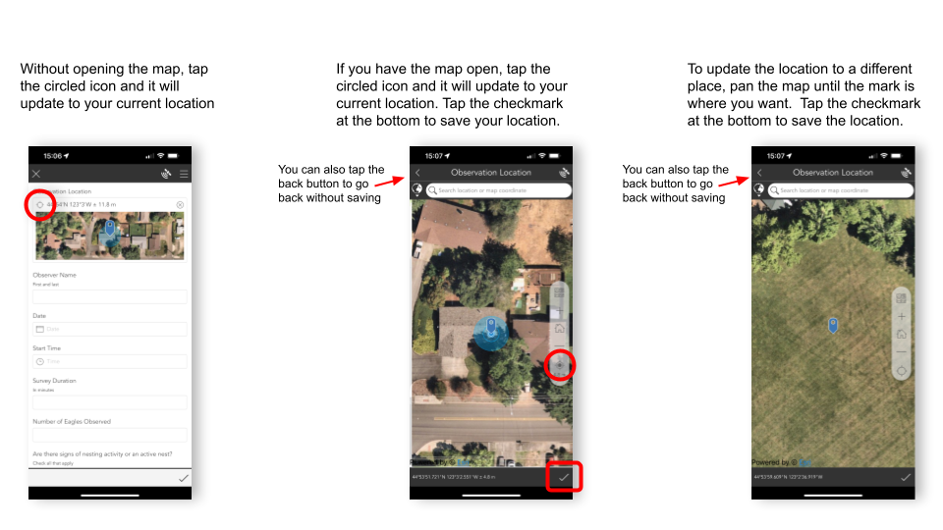

- ESTABLISH NEST OCCUPANCY: Look for signs that the nest is occupied/active. Obvious signs of occupancy are listed below (a-f), as well as some not so obvious signs (g-j) which typically require a trained observer to identify. The presence of any of these signs might indicate an active/occupied nest; however, if a nest is active, many of these signs will usually be observed. Document all signs of nest occupancy that you observe using the checkboxes in Survey123.
  - An eagle or pair of eagles present on or near the nest in question
  - An eagle or pair of eagles present in or near the nest tree
  - An eagle(s) carrying a stick to or near the nest
  - An eagle carrying a prey item to the nest
  - An eagle in incubating position in the nest (usually head observed only)
  - Chicks / nestlings in the nest
  - An eagle or a pair of eagles perched in the vicinity of the nest in question
  - Fresh sticks / greenery / other items in nest, or other evidence of nest maintenance
  - Whitewash on branches around nest or on ground/vegetation underneath nest
  - Prey items on the ground underneath the nest
- TALLY TRAIL USERS: Keep a rough tally of the number of people you see using the trail in front of the eagle nest during your observation period. You will be asked to give an estimate of the number of trail users in Survey123.
- BEHAVIOR MONITORING: Keep an eye out for activities that cross within a close proximity to the nest (basically closer to the nest than you are at your observation station). As the activity approaches the nesting area, watch the eagle(s) for behavior changes. In Survey123 indicate what type of activity you observed. When you select “yes” for any given activity, a new question will appear that asks whether the activity disturbed the eagle(s). If the eagle(s) exhibit any of the behaviors listed under “Signs that an eagle is agitated or disturbed by an activity” below, select yes. Otherwise, select no. If you did not observe eagles at the time the activity occurred, select no. Add any details about the observed behaviors in the notes/comments field.
Signs that an eagle is agitated or disturbed by an activity include:
    - Eagle’s attention focused on the activity and/or human presence in the vicinity
    - Eagle performs vocalizations (either while perched or in flight) during activity and/or human presence
    - Eagle takes flight during activity and does not return until activity ceases (or there is a break in activity)
    - Eagle takes flight, immediately returns, and takes flight again
    - Other: individual eagles may tolerate activities differently and may respond to disturbances with different behavior.
Normal eagle behavior indicating eagle is likely not bothered by the activity includes:
    - Eagle’s attention is NOT focused on the activity and/or human presence in the vicinity (i.e.- eagle is looking elsewhere)
    - Eagle is “preening” (using beak to groom feathers)
    - Eagle is attending young (i.e.- feeding, brooding), if present.
    - Eagle brings prey to nest while activity is being conducted.
- SUCCESS/PRODUCTIVITY: If you see any young eaglets in or near the nest during your observation period, make sure to document this and the number present in Survey123 (generally 1 or 2 young are present in a nest, but occasionally 3 can be present). Once we confirm that there are young present, we will let all volunteers know so they can be aware to watch for them during their monitoring surveys. Monitoring will continue until young are fledged.

- Photographs: Photographs of the eagles or nest are not required, and it is likely to be difficult to capture good pictures with your cellphone at such a distance. If you happen to get good shot though, please share it. And if you happen to have a telephoto lens and would like to share high quality pictures, please do! You can upload them to Survey123 or email them to Amanda Sitter at ASitter@cityofsalem.net.

The types of pictures you are more likely to take and upload to Survey123 during your observation periods are of activities taking place, particularly those that are either not typical uses or that appear to disturb the eagles in some way. Please upload these types of photos along with your survey in Survey123 and use the comments field to provide context.

- At the end of your observation period review your answers in Survey123 and make sure you have completed all the questions and entered any notes. If you are not sure about something you saw or heard, put it in the notes.
Keep in mind that knowing when eagles were NOT present is also very important to this effort. So even if you go to the site, watch for 2 hours, and do not see a single eagle, make sure to complete the survey form.

Once you have completed all the questions, uploaded any pictures, and reviewed your answers, submit your survey using the appropriate button on your device (usually a check mark at the bottom of the screen).
*If you need to report an incident or potentially inappropriate activity, please call the Public Works Dispatch at 503-588-6063.

