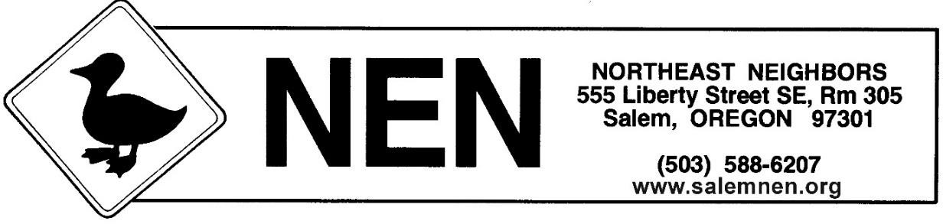

Northeast Neighbors www.SalemNEN.org

NEN Zoom Meeting

This is an open meeting; the public is invited.

For more information, call 503-970-1319
Email: SalemNEN@gmail.com Website: SalemNEN.org

Tues., March 12, 2024
6:30 pm to 8:15 pm

Please check our website for the link to our Zoom meeting.

AGENDA
- Welcome and Announcements
- Approve February Minutes
- Police Officer Report
- City Councilor Reports
- Salem’s Emergency Manager- CERT
- Revenue Task Force Discussion
- Other Business
- Next Meeting

Meeting Date
NEN meets once a month at 6:30 p.m.
To view your neighborhood page and sign up for meeting announcements: www.cityofsalem.net/nen
on the 2nd Tuesday of each month year-round

