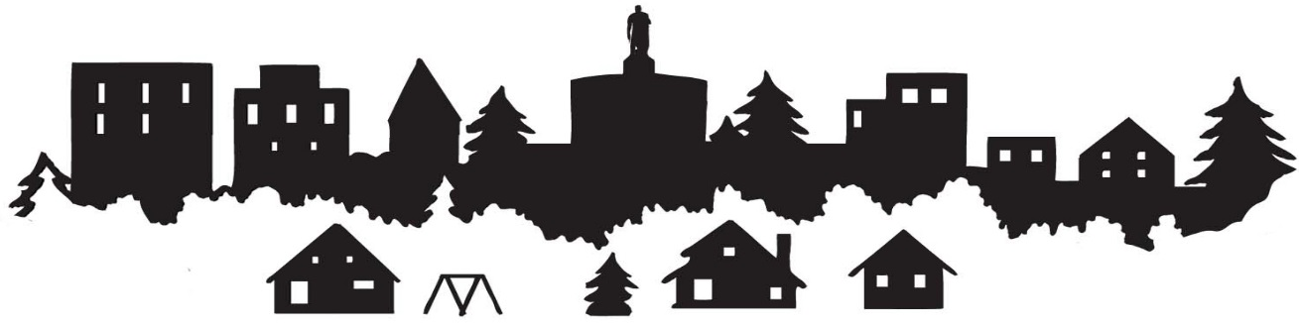

CITY OF SALEM’S NEIGHBORHOOD ASSOCIATION
BOARD TRANSITION PLAN
PURPOSE
This document can be completed as a resource to identify key NA operations and partners. It can be used to share with current board members, train new board members, and to provide a smooth and consistent transition when a new chairperson is elected.

HOW TO COMPLETE
This document should be divided among board members to collect information and complete each section. It is recommended that this resource be updated yearly to maintain its effectiveness.

SHARING & STORING
It is important to share this information with relevant members of the board so those members could easily train a new chairperson or assist with neighborhood projects. This resource can be shared with board members by email or on a listserv (like Google or Yahoo). As well, sharing the document with the City’s Neighborhood Services Coordinator will ensure access for future board members and to help continue great communication between board members and the City.

NOTE
This document can also be useful in helping to establish your neighborhood association’s annual goals. Taking an inventory of current partners, volunteers and communication strategies can reveal ways in which your association can grow and thrive in the future.

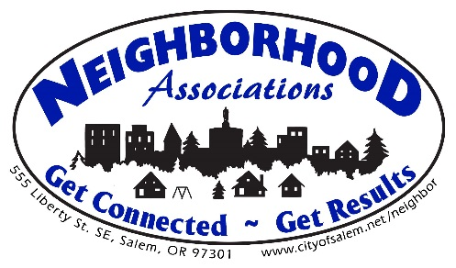
BOARD MEMBER ROSTER UPDATE
An updated roster is required to be submitted annually to the City of Salem’s Neighborhood Services Coordinator. It is also a useful tool for new board members who will need to communicate with other board members or committee members.
First Name | Last Name | Position on  Board | Committee  Assignment | Email | Phone | Physical  Address | Term of  Service

NEIGHBORHOOD ASSOCIATION PARTNERSHIPS
Partners can provide resources such as meeting & event locations, donations, loaning of equipment, and other services. List the organizations (businesses, non-profits, churches, clubs, schools, etc.) that partner with your NA and their role.

Name of  Organization | Contact Person | Phone | Email | How They Partner

COMMUNICATIONS
List the media resources that the NA utilizes to inform neighbors of meetings and other events. Include newspapers, newsletters of partnering organizations, bulletin boards, radio stations, special event flyers, etc.

Media Outlet | Contact Person | Phone | Email | Purpose

NA SOCIAL MEDIA SITES/WEBSITE
List all of the social media sites (Facebook, Twitter, Instagram, Google, etc.) used by the NA and any additional instruction or information that may be needed for maintenance.

Social Media Site | User Name | Password | Other Information

VOLUNTEERS
List any volunteers, excluding NA board & committee members, who assist with resources, projects and events. Also include any organizations whose volunteers assist the NA.

Organization | Volunteer Name or Organization Contact | Phone | Email | Volunteer Role

EVENTS, PROJECTS, and FUNDRAISERS
List any events or projects that the NA coordinates on a regular/annual basis and identify any fundraising activities that occur throughout the year.

Event | Coordinator Name | Phone & Email | Date of Event | Other  Information

NA MEETING DATE, TIME, & LOCATION
List the day each month that the NA meets (i.e. the third Tuesday) along with the time and location. List any other relevant information as well, such as meetings are held every odd month and explain how your meeting location is reserved, along with contact information if relevant.

Date | Time | Location | Contact Information | Other Information

NEIGHBORHOOD PARTNERSHIP PROGRAM

If your Neighborhood Association participates in the City’s Neighborhood Partnership (NP) Program, please list the program, the contact person, along with their contact information, and the responsibilities of the NA. If you would like more information about the NP Program, contact Jessica Loewen-Preis at
503-540-2329 or at jlpreis@cityofsalem.net.
Partnership Program Name | Contact Person | Contact Information | Role of the NA

Notes:
______________________________________________________________________________________________________________________________________________________________________________________________________________________________________________________________________________________________________________________________________________________________________________________________________________________________________________________________________________________________________________________________________________________________________________________________________________________________________________________________________________________________________________________________________________________________________________________________________________________________________________________________________________________________________________________________________________________________________________________________________________________________________________________________________________________________________________________________________________________________________________________________________________________________________________________________________________________________________________________________________________________________________________________________________________________________________________________________________________________________________________________________________________________________________________________________________________________________

Questions?
For further information or resources, contact Irma O. Dowd, Neighborhood Services Coordinator at
503-540-2303 or idowd@cityofsalem.net

